Backtracking
The principal idea of backtracking is to construct solutions one component at a time and evaluate such partially constructed candidates as follows. The partially constructed solutions can be developed further by taking the first remaining legitimate option for the next component. If there is no legitimate option for the next component, no alternatives for any remaining component need to be considered. In this case, the algorithm backtracks to replace the last component of the partially constructed solution with its next option.
Backtracking approach is implemented by constructing a tree, called the state-space tree. Its root represents an initial state before the search for a solution begins. The nodes of the first level in the tree represents the choices made for the first component of a solution, the nodes of the second level in the tree represents the choices made for the second component and so on.
A node in a state-space tree is said to be promising if it corresponds to a partially constructed solution that may still lead to a complete solution, otherwise, it is called nonpromising.
n-Queens Problem
The problem is to place n queens on an n-by-n chessboard so that no two queens attack each other by being in the same row or in the same column or on the same diagonal. It can be seen that for n =1, the problem has a trivial solution, and no solution exists for n =2 and n =3. The implicit tree for 4 - queen problem for a solution (2, 4, 1, 3) is as follows:
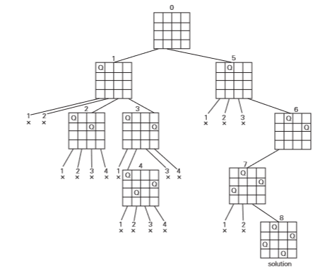
Hamiltonian Circuit Problem
Given a graph G = (V, E) we have to find the Hamiltonian Circuit using Backtracking approach. We start our search from any arbitrary vertex say 'a.' This vertex 'a' becomes the root of our implicit tree. The first element of our partial solution is the first intermediate vertex of the Hamiltonian Cycle that is to be constructed. The next adjacent vertex is selected by alphabetical order. If at any stage any arbitrary vertex makes a cycle with any vertex other than vertex 'a' then we say that dead end is reached. In this case, we backtrack one step, and again the search begins by selecting another vertex and backtrack the element from the partial; solution must be removed. The search using backtracking is successful if a Hamiltonian Cycle is obtained.
Example: Consider a graph G = (V, E) shown in fig. we have to find a Hamiltonian circuit using Backtracking method.
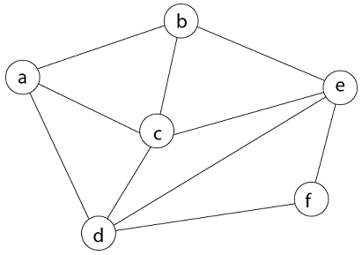
Solution: Firstly, we start our search with vertex 'a.' this vertex 'a' becomes the root of our implicit tree.
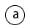
Next, we choose vertex 'b' adjacent to 'a' as it comes first in lexicographical order (b, c, d).
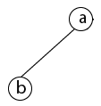
Next, we select 'c' adjacent to 'b.'
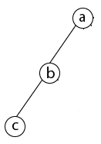
Next, we select 'd' adjacent to 'c.'
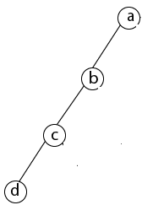
Next, we select 'e' adjacent to 'd.'
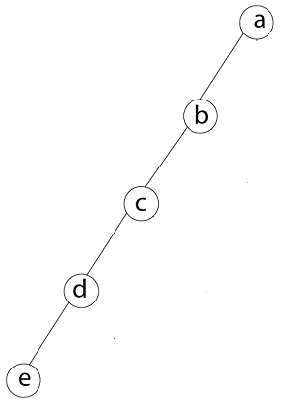
Next, we select vertex 'f' adjacent to 'e.' The vertex adjacent to 'f' is d and e, but they have already visited. Thus, we get the dead end, and we backtrack one step and remove the vertex 'f' from partial solution.
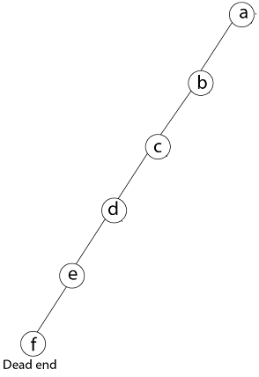
From backtracking, the vertex adjacent to 'e' is b, c, d, and f from which vertex 'f' has already been checked, and b, c, d have already visited. So, again we backtrack one step. Now, the vertex adjacent to d are e, f from which e has already been checked, and adjacent of 'f' are d and e. If 'e' vertex, revisited them we get a dead state. So again we backtrack one step.
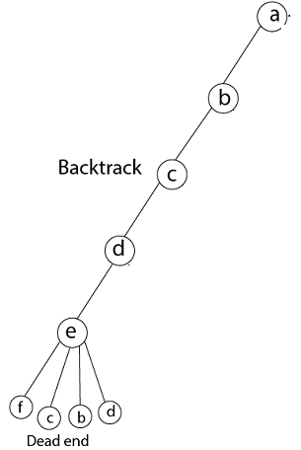
Now, adjacent to c is 'e' and adjacent to 'e' is 'f' and adjacent to 'f' is 'd' and adjacent to 'd' is 'a.' Here, we get the Hamiltonian Cycle as all the vertex other than the start vertex 'a' is visited only once. (a - b - c - e - f -d - a).
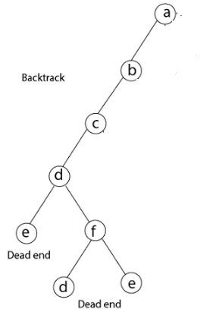

Again Backtrack
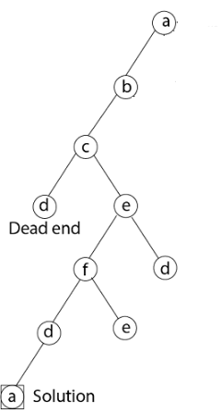

Subset-Sum Problem
The Subset-Sum Problem is to find a subset's' of the given set S = (s_{1,} s_{2,} s_{3,}...,s_{n}) where the elements of the set S are n positive integers in such a manner that s'єS and sum of the elements of subset 's' is equal to some positive integer 'd'
The Subset-Sum Problem can be solved by using the backtracking approach. In this implicit tree is a binary tree. The root of the tree is selected in such a way that represents that no decision is yet taken on any input. We assume that the elements of the given set are arranged in increasing order:
s₁ ≤ s₂ ≤ s₃... ≤ s_{n}
The left child of the root node indicated that we have to include 'S1' from the set 'S' and the right child of the root indicates that we have to execute 'S1'. Each node stores the total of the partial solution elements. If at any stage the sum equals to 'X' then the search is successful and terminates.
The dead end in the tree appears only when either of the two inequalities exists:
- The sum of s' is too large i.e.
s'+ s_{i + 1} > d
- The sum of s' is too small i.e.
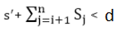
Example: Given a set S = (3, 5, 6, 7) and d =15. Obtain the subset sum using Backtracking approach.
